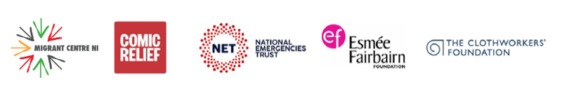

Global Majority Fund - Expression of interest – Questions

This document will help you prepare your answers for our online form.
You cannot save the online form and return to It so please be ready to answer all of the questions.

- Are your beneficiaries resident in Northern Ireland?
Yes
No

- Is your organisation BAME-led and with focus on the needs within BAME communities?
Yes
No

- Is your annual turnover less than £250,000?
Yes
No

- Is your group a 'Not for Profit' group?
Yes
No

- Are you a constituted group with a governing document (e.g. a constitution or articles of association)?
Yes
No

- Does your organisation have a board of trustees / governors / directors?
Yes
No
- Do you have a bank account in the name of the organisation?
Yes
No

- Does your organisation have a Protection of Children and Vulnerable Adults or Safeguarding policy?
Yes
No

- Does your organisation have current public liability insurance?
Yes
No

- Funding you are applying for should NOT promote a single political or religious idea.
Do you confirm that this is true?
Yes
No

- Name of organisation

- Registered address of the organisation

- Your organisation's website address

- Your organisation's Facebook page

- Your organisation's Twitter handle

- Your organisation's other online presence links (TikTok, Instagram, SnapChat, etc.)

- Main Contact person (full name and title)

- E-mail address

- Phone number

- Second contact details please provide full name

- Second contact e-mail address (must be different to main contact)

- Second contact phone number (must be different to main contact)

- Which of the following describes your organisation’s legal structure?

- How much grant funding is requested?

- Are you applying for:
- core costs
- project funds for a continuation
- project funds for a new project
- a combination of the above

- What do you want to use the grant funding for?

Please describe the project, or work that you are undertaking. You should describe:
1) how this proposed work will help your service users deal with the impact of the COVID-19 pandemic,
2) what are the issues you are hoping to address with the money requested,
3) how the requested money will help you to deliver the services,
4) how many service users you are planning to reach.
5) Tell us about the change you are hoping to make and impact on your beneficiaries.

- What are you going to spend the money on?
Please provide a breakdown of what the grant money will be spent on. Provide:
- Budget headings
- Some breakdown of costs
- Amounts in £s
For example:
Volunteer costs - mileage for volunteers at max. 45p per mile for 24 volunteers = £300
Core costs - broadband 12 x £15, electricity 6 months approx. £112 per month, rent 6 months @550 per month = £4152

- Full name of person filling in the application

- I confirm that the organisation named on this proposal has given me authority to submit this proposal on its behalf.
Yes
No

- In order to process your Expression of Interest and potentially invite you to the interview we need to record your details. Please tick the box to acknowledge that you give permission for us to hold your data for grant making purposes.
I agree
I disagree

