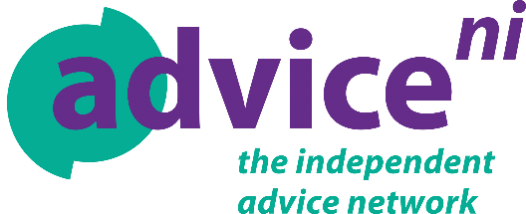

APPLICATION FOR THE POST OF:
Bilingual EUSS Immigration Adviser
Please mark which location you would like be considered for and whether you would like to be considered for full-time or part-time positions only, or both:

Belfast Lurgan Derry~Londonderry

Full-time Part-time Both

Closing date for receipt of applications: 3rd June 2019 no later than 12 noon

Completed applications must be emailed to: recruitment@migrantcentreni.org

ALL APPLICANTS MUST –
- Not submit additional sheets
- Not submit supplementary material such as CVs, as these will not be considered.
- Use font size 12 if completing the application form in typescript. The application should not exceed 10 pages in total

- PERSONAL DETAILS:

Name:

Current Job, including Employer:

Home Address:

Telephone Numbers:

Email Address:

Employment History
Note: please give details of all the posts you have held, starting with your current post, accounting for any gaps in your employment history.

Date  From / To  (Month/year) | Employer’s name address & nature of business | Job title, main responsibilities and major achievements | Final salary and reason for leaving
Using the space below please describe how you meet the essential and desirable (if relevant) criteria as described on the personal specifications document

- Qualification/Education
- Educated to a degree level in relevant subject or other country equivalent or 1 year working experience providing Level 1 or higher immigration advice; Level 1 OISC Immigration training; NI OCN Level 3 or 4 Community Interpreting in any of the following languages: Polish, Slovak, Lithuanian, Bulgarian, Romanian.
Please list your qualifications, accrediting body and educational institutions

- Experience
- Minimum 1 year frontline working experience in voluntary or statutory sector

- Minimum of 200 interpreting hours delivered in a public sector

- Experience of delivering presentations

- Experience of organising and scheduling meetings

- Knowledge
- Understanding of EU Settlement Scheme

- Knowledge of the BME Community

- Knowledge of UK Immigration Regulations

- Abilities, aptitudes and skills
- Demonstrated strong planning and organizational skills

- Demonstrated ability to communicate clearly in both verbal and written English as well as one or more of the 26 EU languages with strong preference for speakers of Polish, Slovak, Lithuanian, Bulgarian and Romanian.

- Demonstrated ability to work to deadlines

- Demonstrated ability to work with groups as well as individuals in an inclusive and participatory matter

- Demonstrated ability to work, communicate and liaise with a range of individuals, voluntary, community and statutory agencies

- Computer literate in Microsoft Office packages and confident in use of Android devices and internet browsers

- Ability to work independently and use own initiative

- Excellent time management skills

- Access to own transport and ability to travel within NI (Consideration will be given to candidates who because of a disability, cannot hold a driving licence but they must be able to access a mode of transport that allows them to fulfil the duties of the post).

- Personal qualities
- Resourcefulness and enthusiasm

- Ability and availability to work flexibly when required to do so including evenings and weekends

- An understanding of the need for confidentiality and the need to treat sensitive information with discretion

- Cultural sensitivity

- Ability to work well in a team

Do you have access to transport to enable you to meet the travel needs of the post?

YES NO

Are you willing to work unsociable hours and weekends if required:

YES NO

Are you eligible to work in the UK?

YES NO

You will be required to provide documentation to prove your right to work in the UK (under Section 8 of the Asylum and Immigration Act 1996) if you are offered the post.

Date:

Name:

Signed:

[this page is intentionally left blanc]

